**Exp: An LED Heart**

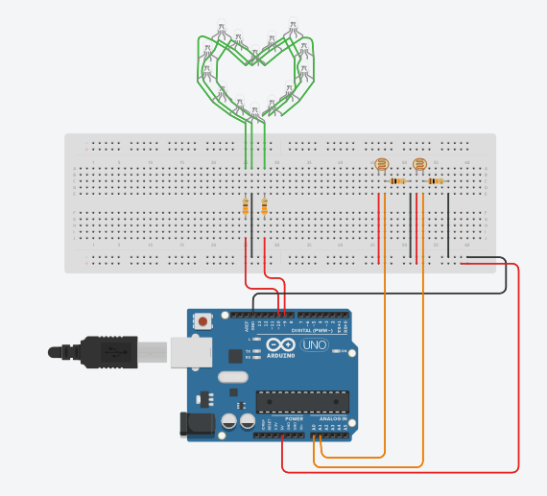

**Theory:**

The Hand-held heart when held in the hand from any one side of the heart then the heart wil blink red 60 times in a minute and if the heart is held from both the sides then the heart will blink green 120 times in a minute.

**Concept used:**

When the heart is exposed in bright light, both the photoresistor or LDR in it will be exposed to the light as well. Therefore there will be change in resistance of LDRs and arduino will read that value. If the value received by arduino from the both LDR is more than the value set in program the heart will not blink. But if the value given to Arduino by one of the LDR is less than the value in program, i.e the heart is held on one side, then the heart will blink red 60 times in a minute and if the value given to Arduino by both of the LDR is less than the value in program, i.e the heart is held on form both sides, then heart will blink green 120 times in a minute.

**Learning & Observations:**

In this experiment I have learned:

1. How to properly setup a LDR.
2. To keep the circuit safe.
3. Multi-functioning of Arduino.

**Problems and Troubleshooting:**

The problems that I had to deal with were:

1. Not being able to properly install the LDR in circuit, which led to hardware failure.
2. Making some of the improperly, which again led to hardware failure.
3. Minor errors in the program caused software malfunction or led to different results than expected.

The problems were a little hard to detect but were taken over as soon as possible.

**Precautions:**

1. Check that the connections in the circuit are made properly.
2. Make sure that the value of resistances is not very low as it might lead to circuit damage.
3. The program must be correct in order for the hardware to work properly.
4. The hardware must be calibrated properly.
5. Make sure that the components used are not faulty.

**Learning Outcomes:**

1. Calibrating the circuit properly.
2. Complex difference between LED and RGB LED.
3. Installing an LDR properly.
4. Different uses of Arduino.